PRATHYUSHA ENGINEERING COLLEGE

COLLEGE CODE : 1114

A PROJECT REPORT

SUBMITTED BY

NAME OF STUDENTS REGISTRATION NUMBER

MADDINA KHUSHIRAM 111421205028

BHARGAVI

VIMAL

NAVYA

GxDENESH

IBM CLOUD NAANMUDHALVAN

IN

PRATHYUSHA ENGINEERING COLLEGE

TO

IBM , ZOHO

COURSE ALLOCATED : “ ”

NAANMUDHALVAN

**NAANMUDHALVAN PROJECT TITLE** : PERSONAL TRAVEL BLOG ON IBM CLOUD STATIC WEB APPS

ANNA UNIVERSITY : CHENNAI 600025 NOV 2023

**PROJECT-1: PERSONAL BLOG ON IBM CLOUD STATIC web apps**

**Problem Statement:** Create a personal travel blog hosted on IBM Cloud Static Web Apps. Share your travel adventures, tips, and captivating photos with the world. Use IBM Cloud Static Web Apps to easily update your blog and document your journeys. Inspire others to explore the beauty of the world and forge unforgettable memories!

**Problem Definition:** The project aims to develop a captivating personal travel blog hosted on IBM Cloud Static Web Apps. The primary objective is to inspire and engage readers by sharing enriching travel experiences, insightful tips, and visually stunning photographs. The overarching goal is to motivate and guide individuals to explore the world, create unforgettable memories, and enhance their overall travel experiences. The project involves multifaceted tasks, including designing an intuitive and appealing blog structure, crafting engaging and informative content, configuring and setting up IBM Cloud Static Web Apps for seamless hosting, and establishing an efficient process for updating the blog to keep it current and engaging.

**Design Thinking:**

**Content Structure:** Develop a basic structure for the blog, including a few sample travel stories, tips, and photos, to visualize how the content will be organized.

**Content Planning:** Brainstorm ideas for organizing travel stories, tips, photos, and maps to optimize the blog's structure for a seamless and engaging user experience.

**Website Prototype:** Create a simple HTML/CSS prototype to demonstrate the website's layout, navigation, and basic interactive features.

**IBM Cloud Setup :** Set up a minimal version of the blog on IBM Cloud to test the hosting functionality and ensure basic deployment works smoothly.

**Content Management Test:** Experiment with a chosen CMS or static site generator to understand its capabilities and how it facilitates content updates.

**User Testing:** Share the MVP with a small group of potential readers for feedback on content relevance, ease of navigation, and overall user experience.

**Technical Testing:** Conduct tests to ensure the blog functions well on various devices, browsers, and platforms, and identify any performance or compatibility issues.

**Feedback Analysis:** Analyse feedback to identify areas for improvement and iteration, including content enhancements, design tweaks, and technical adjustments.

**Website Refinement:** Make necessary design and functionality improvements based on feedback to create a polished and user-friendly blog.

**Innovation:**

1. **Personalized Travel Recommendations:**

Implement a recommendation engine that suggests travel destinations, accommodations, or activities based on users' preferences and past interactions with your blog.

1. **Visual Search:**

Implement visual search functionality, allowing users to search for travel destinations or related content by uploading images they find inspiring.

1. **Real-Time Collaborative Blogging** : Allow multiple authors or contributors to collaborate in real-time on your blog. This can be useful for co-authored articles or expert panel discussions.
2. **Environmental Sustainability Focus** : If your blog's niche aligns with sustainability, incorporate innovative features like carbon footprint tracking, sustainable product recommendations, or eco-friendly lifestyle tools.
3. **Interactive Visual Content**: Incorporate interactive infographics, charts, and diagrams to make complex topics more engaging and understandable. These visuals can be interactive, allowing users to explore data or concepts.
4. **Personalized Content Recommendations** : Implement AI-driven recommendation engines that analyse user behaviour to suggest personalized content, enhancing user retention and satisfaction.

**Implementation Flow Chart :**

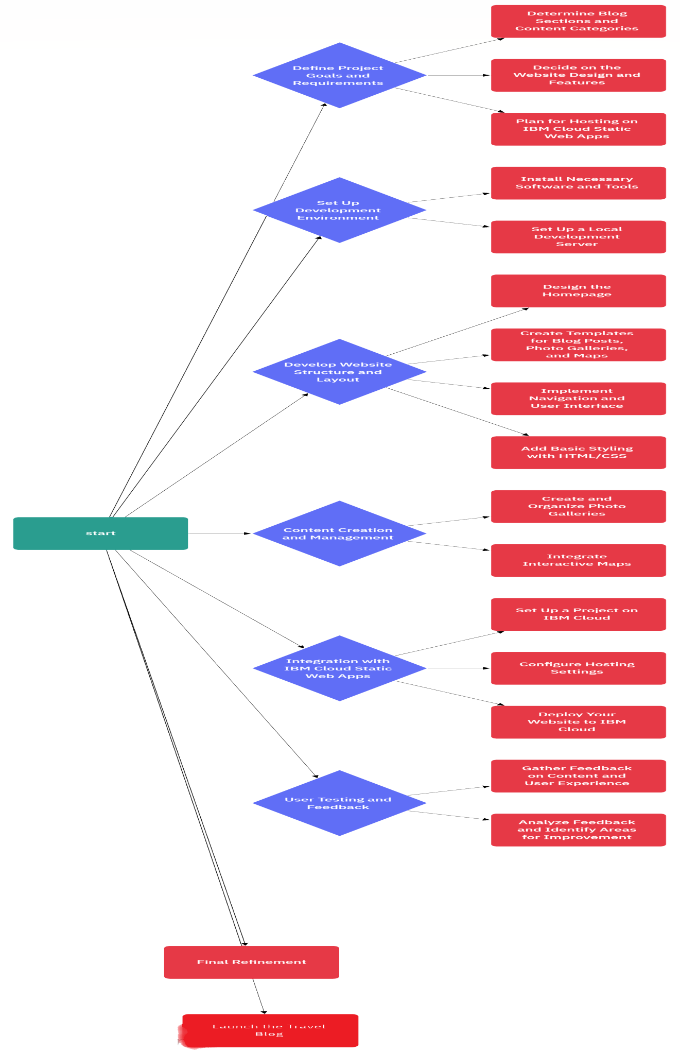

**Development phases :**

REQUIREMENT GATHERING AND ANALYSIS :

* Make understand the purpose of the website.
* Gather content of webpage regarding to personal travel blog.
* List the features and functionalities you want to include.
* Researching similar websites or competitors for inspiration.

PLANNING :

* Choose the technology stack
* 1. HTML 2. CSS
* Planning the website structure.
* Decide on a hosting provider.
* Gather the travel photos and videos you will need.
* Insert navigation bar in the web page for usage of user.

DESIGN :

* Decide on a colour scheme and typography.
* Create or source any graphics, photos or videos you will need.
* Get feedback on the design and make any necessary adjustment.
* Apply different colour effects to the web page for more attraction to website.

Development :

1. Starting with basic structure using HTML.

2. Also using the CSS.

Total This Website Contain Two Parts :

• INDEX page

1. Navigation bar.

2. Posts on travel blog.

• Tourist place spots

1. Tirumala 2. Kanyakumari 3. Taj mahal Code

**Implementation and Structure for web sites :**

**Code : For INDEX page.**

|  |
| --- |
| <!DOCTYPE html>  <html>  <head>    <title>Personal Blog Website</title>  <!--Add CSS Style-->  <link rel="stylesheet" href="css\style.css">  <link rel="stylesheet" href="https://cdnjs.cloudflare.com/ajax/libs/font-awesome/4.7.0/css/fontawesome.min.css">    </head>  <body>  <div id="container" class="container">  <!--Navigation bar-->  <nav id="nav" class="nav">  <div class="nav-menu flex-row">  <div class="nav-brand">  <h3>-----INDIAN TOURISM-----</h3>  </div>  <div>  <ul class="nav-items">  <li class="nav-link">  3  <a href="#nav">Home</a>  </li>  <li class="nav-link">  <a href="#post">Posts</a>  </li>  <li class="nav-link">  <a href="#about">About me</a>  </li>  <li class="nav-link">  <a href="#contact">Contact</a>  </li>  </ul>  </div>  </div>  </nav>  <header class="welcome">  <figure>  <center><img id="welcome-img" src="/welcome.jpeg" alt="Welcome"></center>  </figure>  </header>      <!--Posts section-->  <section id="post" class="post">  <h1><b>Recent Posts</b></h1>  <div class="flex-container">  <div class="post-card">    <h3><center>TIRUMALA</center></h3>  <center><img id="card-img" src="/tirumala.jpeg" alt="Project post"></center>  <p id="hh">Tirumala, set atop the lush Tirumala hills of the Eastern Ghats, is not only a major  spiritual hub due to the renowned Venkateswara Swamy Temple dedicated to Lord Venkateswara but also a place of  breathtaking natural beauty. As one of the world's richest and most visited religious sites, it holds immense  historical significance with its Dravidian architectural marvels, intricate carvings, and a legacy that has  been patronized by various rulers over centuries. Managed by the Tirumala Tirupati Devasthanams, the temple  and its surroundings blend spiritual, historical, and natural allure seamlessly.</p>  <span class="date-post"><i class="fa fa-calendar"></i>&nbsp;&nbsp; Nov, 15 2020</span><br><br>    <input type="button" onclick="window.open('blog.html', '_blank')" value="Read more" class="btn-button  btn-readmore">  </div>  <div class="post-card">  <h3><center>Kanyakumari</center></h3>  4  <center><img id="card-img" src="/kanya1.jpg" alt="Development post"></center>  <p id="hh"> Kanyakumari is the southern tip of India.This place has been a great center for art,  culture, civilization, and pilgrimage for years. It was also a famous center for commerce and trade.  This gigantic statue was built by the Tamil government in honour of the Saint  Thiruvalluvar which is now one of the key attraction in Kanyakumari.</p>  </p>  <span class="date-post"><i class="fa fa-calendar"></i>&nbsp;&nbsp; Nov, 10 2020</span><br><br>  <input type="button" onclick="window.open('blog1.html', '_blank')" value="Read more" class="btn-button btnreadmore">  </div>  <div class="post-card">  <h3><center>Taj Mahal</center></h3>  <center><img id="card-img" src="tajmahalnew.jpg" alt="Agile post"></center>  <p id="hh">Taj Mahal, one of the new 7 wonders of the World.Taj Mahal is situated on the banks of river  Yamuna in the North Indian city of Agra.  It was commissioned by Shah Jahan, the Mughal emperor for housing the tomb of his  beloved wife,  Mumtaz Mahal. Hence, it’s also considered as the ultimate “symbol of love”  </p>  <span class="date-post"><i class="fa fa-calendar"></i>&nbsp;&nbsp; Nov, 01 2020</span><br><br>  <input type="button" onclick="window.open('blog2.html', '_blank')" value="Read more" class="btn-button btnreadmore">  </div>  </div>  </section>  <!--About me section-->  <section id="about" class="about">  <h1>About me</h1>  <div class="about-content-grid">  <div class="about-box"><br>  <center><img id="card-img" src="/khushiramit.jpeg" alt="Agile post" width="200"  height="200"></center>  <p id="hh">Hello, This is khushiram from chennai,India. I'm thrilled to have you join me on  this journey through the world's most captivating destinations.  I've always had a deep passion for travel and a curiosity to explore the diverse cultures  and landscapes that our planet has to offer. Over the years, I've had the privilege of visiting numerous  countries, each with its unique charm and beauty.    Through this blog, I aim to share my adventures, travel tips, and insights gained from my  explorations. Whether you're a seasoned traveler or planning your first big adventure, I hope my experiences  and recommendations will inspire and guide you on your own voyages.  5    </p>  </div>  </div>  </section>  <!--Contact me and subscribe by form section-->  <section id="contact" class="contact">  <h1>Contact me and Subscribe</h1>  <form class="form-contact">  <label class="text-form" for="fullname">* Name: </label><br>  <input type="text" id="name" name="fullname" placeholder="Write your lovely name"  required><br><br>  <label class="text-form" for="email">* Email: </label><br>  <input type="email" id="email" name="email" placeholder="Email address please"  required><br><br>  <label class="text-form" for="message">Message: </label><br>  <textarea id="message" name="message"></textarea><br>  <input class="btn-button btn-submit" type="submit" value="Subscribe">  </form>  </section>  <!--Footer section-->  <footer class="footer">  <div id="footer-grid">  <div id="follow" class="footer-box">  <h3>Follow me</h3>  <a href="https://www.facebook.com/lovely.khushiramchoudary" class="fa fa-facebook"></a>  <a href="https://twitter.com/?lang=en-in" class="fa fa-twitter"></a>  <a href="https://www.youtube.com/" class="fa fa-youtube"></a>  <a href="https://www.instagram.com/khushiram_maddina/" class="fa fa-instagram"></a>  </div>  <div id="arrow-up">  <a href="#nav" class="fa fa-arrow-circle-up"></a>  </div>  </div>  </footer>  </div>  </body>  </html> |

Output:

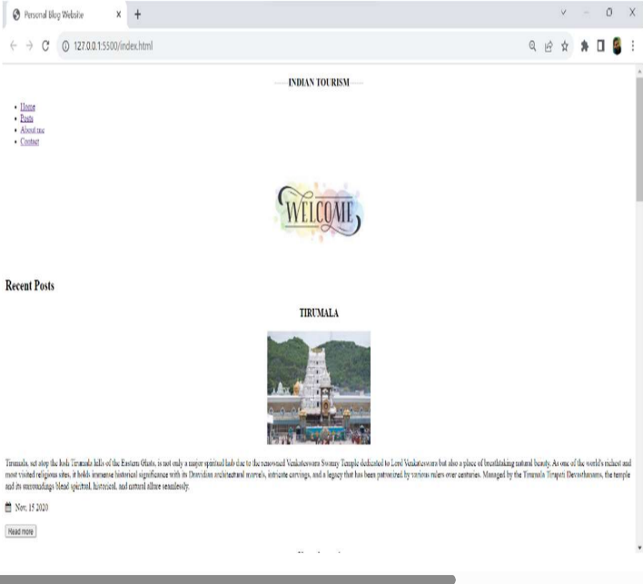 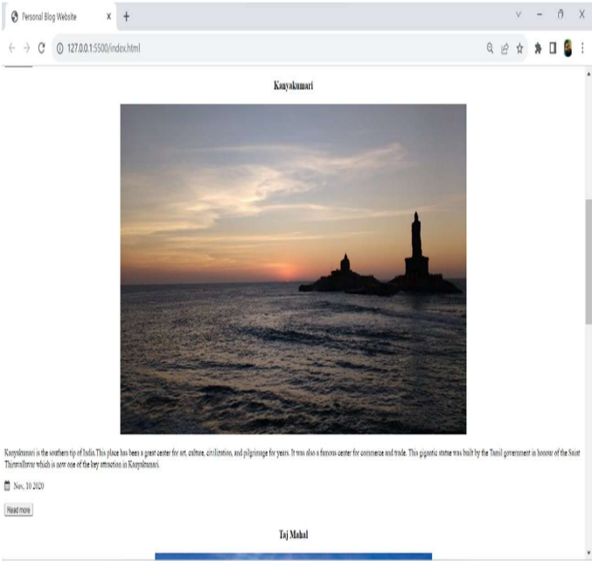

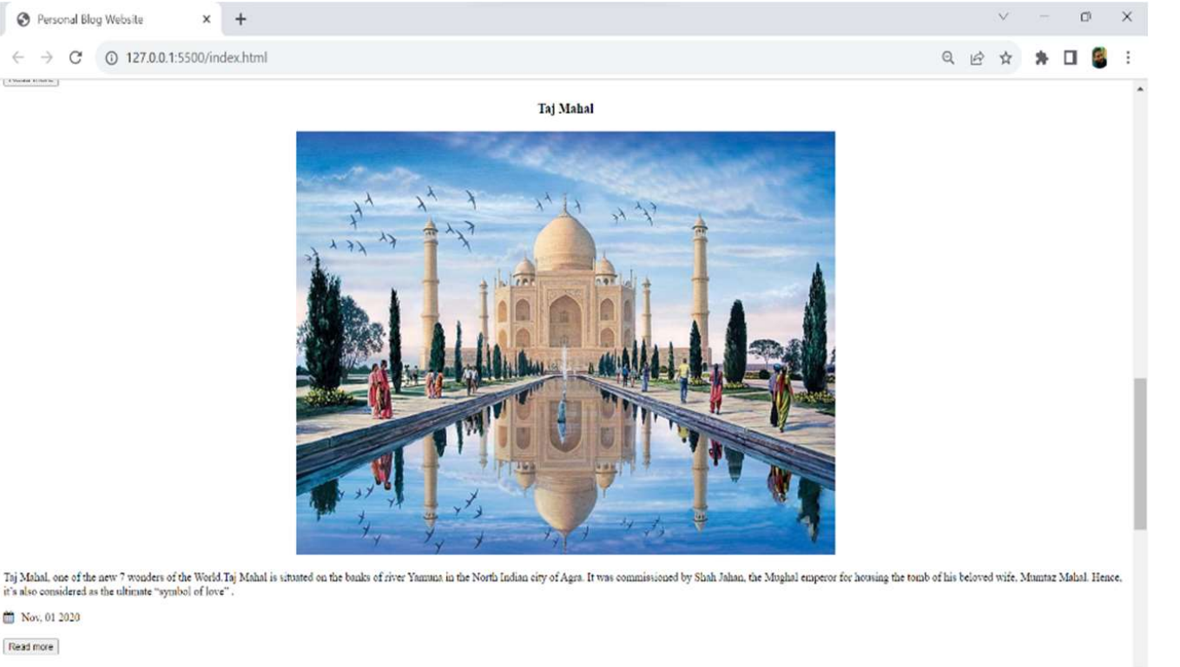

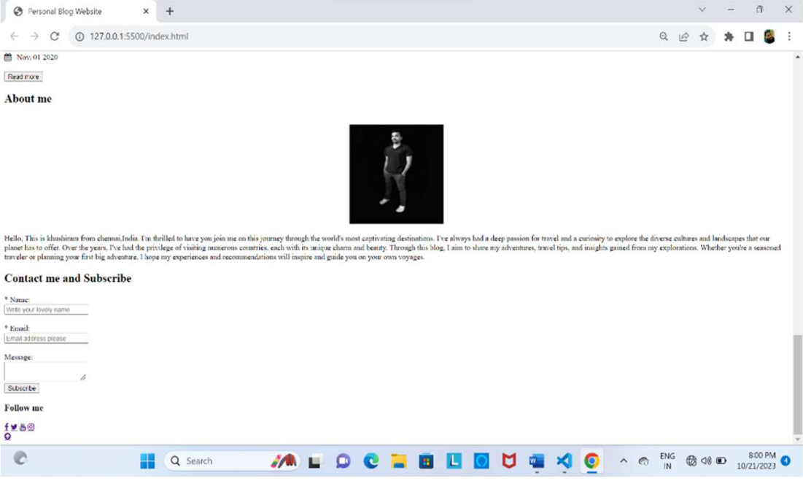

**Applying advanced html and css codes for styling the webpages :**

**Index Html code:**

|  |
| --- |
| <!DOCTYPE html>  <html>  <head>      <title>Personal Blog Website</title>      <!--Add CSS Style-->      <link rel="stylesheet" href="css\style.css">      <link rel="stylesheet" href="https://cdnjs.cloudflare.com/ajax/libs/font-awesome/4.7.0/css/font-awesome.min.css">      <link rel="stylesheet" href="./index.css">  </head>  <body>      <div id="container" class="container">          <!--Navigation bar-->          <nav id="nav" class="nav">              <div class="nav-menu flex-row">                  <div class="nav-brand">                     <CENTER><h3>------INDIAN TOURISM------</h3></CENTER>                     <hr>                  </div>                  <div>                    <ul class="nav-items">                      <li class="nav-link">                        <a href="#nav">Home</a>                      </li>                      <li class="nav-link">                          <a href="#post">Posts</a>                        </li>                      <li class="nav-link">                        <a href="#about">About me</a>                      </li>                      <li class="nav-link">                        <a href="#contact">Contact</a>                      </li>                    </ul>                    <hr>                   </div>              </div>          </nav>          <header class="welcome">              <figure>                  <center><img id="welcome-img" src="/welcome.jpeg" alt="Welcome"></center>              </figure>          </header>          <!--Posts section-->          <section id="post" class="post">              <h1><b>Recent Posts</b></h1>              <div class="flex-container">                  <div class="post-card">                        <h3><center>TIRUMALA</center></h3>                      <center><img id="card-img" src="/tirumala.jpeg" alt="Project post"></center>                      <p id="hh">Tirumala, set atop the lush Tirumala hills of the Eastern Ghats, is not only a major spiritual hub due to the renowned Venkateswara Swamy Temple dedicated to Lord Venkateswara but also a place of breathtaking natural beauty. As one of the world's richest and most visited religious sites, it holds immense historical significance with its Dravidian architectural marvels, intricate carvings, and a legacy that has been patronized by various rulers over centuries. Managed by the Tirumala Tirupati Devasthanams, the temple and its surroundings blend spiritual, historical, and natural allure seamlessly.</p>                      <span class="date-post"><i class="fa fa-calendar"></i>&nbsp;&nbsp; Nov, 15 2020</span><br><br>                      <div class="readbtn">                          <a href="./blog.html" class="btntxt">READMORE</a>                      </div>                  </div>                  <div class="post-card">                      <h3><center>Kanyakumari</center></h3>                      <center><img id="card-img" src="/kanya1.jpg" alt="Development post"></center>                      <p id="hh"> Kanyakumari is the southern tip of India.This place has been a great center for art, culture, civilization, and pilgrimage for years. It was also a famous center for commerce and trade.                          This gigantic statue was built by the Tamil government in honour of the Saint Thiruvalluvar which is now one of the key attraction in Kanyakumari.</p>                      </p>                      <span class="date-post"><i class="fa fa-calendar"></i>&nbsp;&nbsp; Nov, 10 2020</span><br><br>                      <div class="readbtn">                          <a href="./blog.html" class="btntxt">READMORE</a>                      </div>                  </div>                  <div class="post-card">                      <h3><center>Taj Mahal</center></h3>                      <center><img id="card-img" src="tajmahalnew.jpg" alt="Agile post"></center>                      <p id="hh">Taj Mahal, one of the new 7 wonders of the World.Taj Mahal is situated on the banks of river Yamuna in the North Indian city of Agra.                         It was commissioned by Shah Jahan, the Mughal emperor for housing the tomb of his beloved wife,                          Mumtaz Mahal. Hence, it’s also considered as the ultimate “symbol of love”                          .</p>                      <span class="date-post"><i class="fa fa-calendar"></i>&nbsp;&nbsp; Nov, 01 2020</span><br><br>                      <div class="readbtn">                          <a href="./blog.html" class="btntxt">READMORE</a>                      </div>                  </div>              </div>          </section>          <!--About me section-->          <section id="about" class="about">              <h1>About me</h1>              <div class="about-content-grid">                  <div class="about-box"><br>                      <center><img id="card-img" src="/khushiramit.jpeg" alt="Agile post" width="200" height="200"></center>                    <p id="hh">Hello, This is khushiram from chennai,India. I'm thrilled to have you join me on this journey through the world's most captivating destinations.                      I've always had a deep passion for travel and a curiosity to explore the diverse cultures and landscapes that our planet has to offer. Over the years, I've had the privilege of visiting numerous countries, each with its unique charm and beauty.                        Through this blog, I aim to share my adventures, travel tips, and insights gained from my explorations. Whether you're a seasoned traveler or planning your first big adventure, I hope my experiences and recommendations will inspire and guide you on your own voyages.                    </p>                  </div>              </div>          </section>          <!--Contact me and subscribe by form section-->          <section id="contact" class="contact">              <h1>Contact me and Subscribe</h1>              <a class="form-contact">                  <label class="text-form" for="fullname" style="font-size: 2rem;">* Name: </label><br>                  <a class="text-form"><input type="text" id="name" name="fullname"  placeholder="Enter Your Name " required></a><br><br>                  <label class="text-form" style="font-size: 2rem;"><label class="text-form" for="email">* Email: </label><br>                  <a class="text-form"><input type="email" id="email" name="email"  placeholder="Email address please" required></a><br><br>                  <label class="text-form" for="message">Message: </label><br>                  <a class="text-form"><textarea id="message" name="message" placeholder="Enter your mesage here"></textarea><br></a>                  <a style="font-size: 2rem;" class="text-form"><input class="btn-button btn-submit" type="submit" value="Subscribe"></a>              </form>          </section>          <!--Footer section-->          <footer class="footer">              <div id="footer-grid">                  <div id="follow" class="footer-box">                      <h3>Follow me</h3>                      <a href="https://www.facebook.com/lovely.khushiramchoudary" class="fa fa-facebook"></a>                      <a href="https://twitter.com/?lang=en-in" class="fa fa-twitter"></a>                      <a href="https://www.youtube.com/" class="fa fa-youtube"></a>                      <a href="https://www.instagram.com/khushiram_maddina/" class="fa fa-instagram"></a>                  </div>                  <div id="arrow-up">                      <a href="#nav" class="fa fa-arrow-circle-up"></a>                  </div>              </div>          </footer>      </div>  </body>  </html> |

**CSS code for index page :**

|  |
| --- |
| l{      list-style: none;      font-size: 2rem;      display: flex;      align-items: center;      justify-content: space-between;  }  body{      margin: 0;      padding: 0;      height: 100vh;      background: linear-gradient(45deg, #FF5733 50%, #3498DB 50%);  }  .readbtn{      height: 5rem;      font-size: 1.5rem;      display: flex;      align-items: center;      justify-content: center;  }  .btntxt{      background-color: aliceblue;      width: 9rem;      height: 2rem;  }  p{      color: white;      font-size: 2rem;  }  .text-form{      display: flex;      align-items: center;      justify-content: center;  }  .footer-box{      display: flex;      align-items: center;      justify-content: space-around;      font-size: 3rem;  } |

**Outputs :**

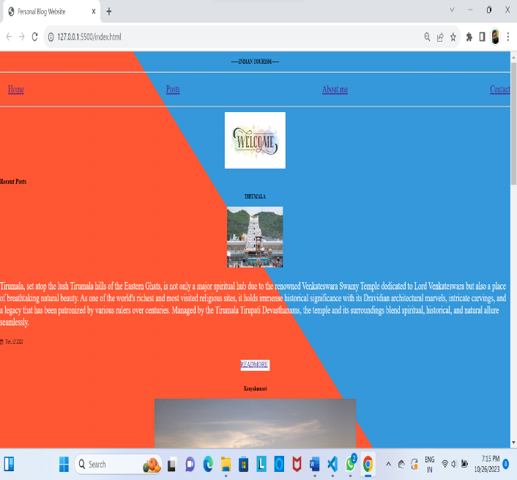 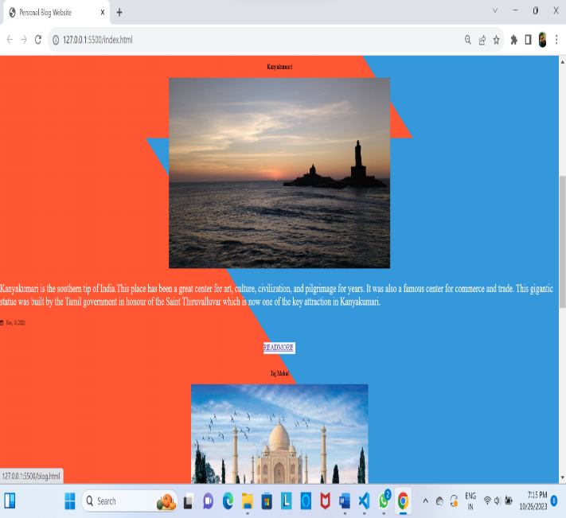

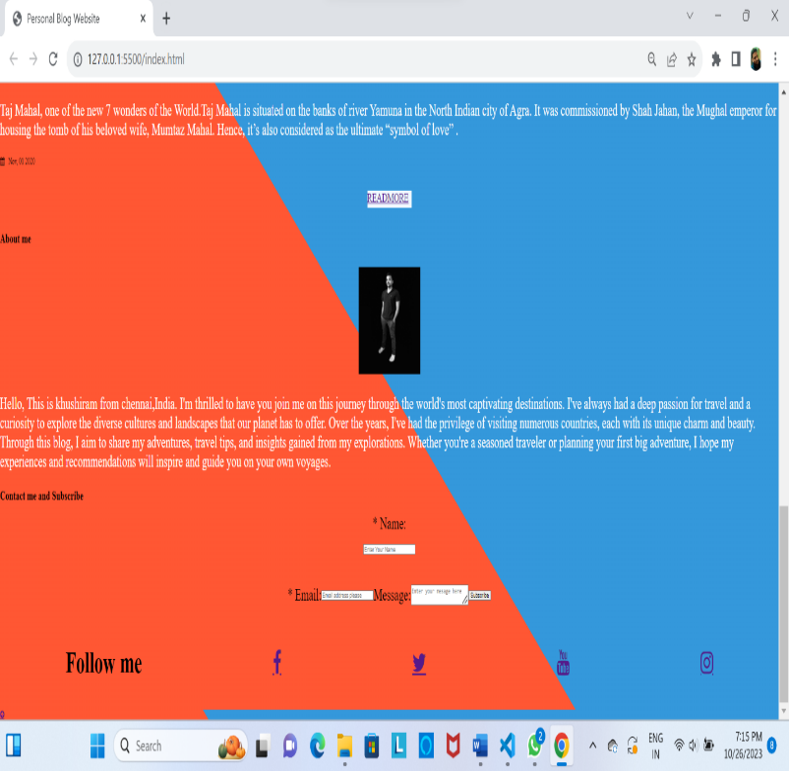

**Implementation code for the tourist places :**

|  |
| --- |
| <!DOCTYPE html>  <html lang>  <head>      <title>TIRUMALA</title>      <!--CSS Blog post-->      <link rel="stylesheet" href="css\post.css">      <!-- Add icon library -->      <link rel="stylesheet" href="https://cdnjs.cloudflare.com/ajax/libs/font-awesome/4.7.0/css/font-awesome.min.css">      <link rel="stylesheet" href="./blog.css">  </head>  <body>      <div id="container-post" class="container-post">          <!--Navigation bar-->          <nav id="nav"class="nav">              <div class="nav-menu flex-row">                  <div class="nav-brand">                     <center><h3>------INDIAN TOURISM------</h3></center>                  </div>                  <div>                    <ul class="nav-items">                      <li class="nav-link">                        <a href="index.html#nav">Home</a>                      </li>                      <li class="nav-link">                          <a href="index.html#post">Posts</a>                        </li>                      <li class="nav-link">                        <a href="index.html#about">About me</a>                      </li>                      <li class="nav-link">                        <a href="index.html#contact">Contact</a>                      </li>                    </ul>                   </div>              </div>          </nav>          <!--Post section-->          <section class="post">              <div class="post-box">                  <h1>TIRUMALA</h1>                  <span class="date-post"><i class="fa fa-calendar"></i>&nbsp;&nbsp; Nov, 15 2020</span><br><br>                  <center><img id="img-post" src="/tirumala1.jpeg" alt="Project"></center>                  <p id="post-p1"><h2>Tirumala is a hill town in the Chittoor district of the southern Indian state of Andhra Pradesh. It is most famous for the Sri Venkateswara Temple, dedicated to Lord Venkateswara (a form of the Hindu god Vishnu). This temple is one of the most visited religious sites in the world. Pilgrims from all over the country and even from abroad come to seek blessings and offer their prayers. The temple complex is managed by the Tirumala Tirupati Devasthanams (TTD) trust. The laddu prasadam offered at this temple is also very popular. The natural beauty of the seven hills surrounding the temple further enhances the spiritual ambiance of the place.</h2>                    <br>                  <h2 id="hello">FOOT PATH FOR TIRUMALA</h2>                  <center><img id="fl1" src="/tirumalafoot.jpeg"></center>                  <center><img id="fl1" src="/tirumalafoot1.jpeg"></center>                  <h3><p id="post-p1">Tirumala has two main footpaths, known as Sopanamargas, that lead to the temple:</p></h3><br>                  <p>1.Alipiri Mettu: This is the older and longer route, starting from Alipiri at the foot of the hills. It's approximately 11 km in length and consists of 3,550 steps. Pilgrims pass through the Galigopuram gateway which has an arch with an emblem of the conch and disc, symbols associated with Lord Vishnu. Many devotees prefer this path as an act of devotion, walking barefoot and often chanting prayers along the way.</p><br>                  <p>2.Srivari Mettu: Located near the village of Srinivasa Mangapuram, this is a shorter route, about 2.1 km long with around 2,400 steps. It's a steeper climb but offers beautiful views of the lush landscape.</p><br>                      <h2>FAMOUS ITEM IN TIRUMALA</h2>                      <center><img id="fl1" src="/tirumalaladdu.jpeg"></center>                      <p id="post-p">The Tirumala laddu is a distinctive prasadam, bestowed upon devotees at the revered Lord Venkateswara temple in Tirumala, Andhra Pradesh. Crafted with ingredients like gram flour, sugar, ghee, cashew nuts, and cardamom, this sizable sweet carries a unique taste rooted in its time-honored preparation method. In 2009, its cultural and regional importance was further highlighted when it received the Geographical Indication (GI) status, ensuring that only laddus made at this temple could bear the prestigious "Tirumala Laddu" label.</p                      <h2>LORD VENKATESHWARA</h2>                      <center><img id="fl1" src="/lordvenkate.jpeg"></center>                      <p id="post-p">Lord Venkateshwara, also known as Balaji, Srinivasa, and Tirupati Balaji, is a manifestation of the Hindu god Vishnu, predominantly worshipped in South India. He is revered as the "Lord of the Seven Hills" due to his abode on the seventh hill of the Tirumala Hills in Tirupati. A widely-believed legend narrates that he borrowed from Kubera, the god of wealth, for his marriage to Padmavathi. Devotees, in their unwavering faith, continue to offer wealth at the Tirumala temple, which stands as an act of helping the deity repay this ancient debt</p>              </div>              <section id="contact1" class="contact1">                  <h1>Write your review on this blog</h1>                  <form class="form-contact">                      <label class="text-form" for="fullname">* Name: </label><br>                      <input type="text" id="name" name="fullname"  placeholder="Write your lovely name" required><br><br>                      <label class="text-form" for="email">* Email: </label><br>                      <input type="email" id="email" name="email"  placeholder="Email address please" required><br><br>                      <label class="text-form" for="message">Feedback </label><br>                      <textarea id="message" name="message"></textarea><br>                      <input class=" btn-submit" type="submit" value="Submit">                  </form>              </section>              <br>              <footer class="footer">                  <div id="footer-grid">                      <div id="follow" class="footer-box">                          <h3>Follow me</h3>                          <a href="https://en-gb.facebook.com/login.php" class="fa fa-facebook"></a>                          <a href="https://twitter.com/?lang=en-in" class="fa fa-twitter"></a>                          <a href="https://www.youtube.com/" class="fa fa-youtube"></a>                          <a href="https://instagram.com/its__praveen_here_?igshid=NGVhN2U2NjQ0Yg==" class="fa fa-instagram"></a>                      </div>                      <br>                      <div id="arrow-up">                          <a href="#nav" class="fa fa-arrow-circle-up"></a>                      </div>                  </div>              </footer>          </section> <!--Footer section--></div>  </body>  </html> |

**Implementation Advanced CSS code for blog 1 :**

|  |
| --- |
| ul{      list-style: none;      font-size: 2rem;      display: flex;      align-items: center;      justify-content: space-between;  }  body{      margin: 0;      padding: 0;      height: 100vh;      background: linear-gradient(45deg, #FF5733 50%, #3498DB 50%);  }  .readbtn{      height: 5rem;      font-size: 1.5rem;      display: flex;      align-items: center;      justify-content: center;  }  .btntxt{      background-color: aliceblue;      width: 9rem;      height: 2rem;  }  p{      color: white;      font-size: 2rem;  }  .text-form{      display: flex;      align-items: center;      justify-content: center;  }  .footer-box{      display: flex;      align-items: center;      justify-content: space-around;      font-size: 3rem;  } |

**Output :**

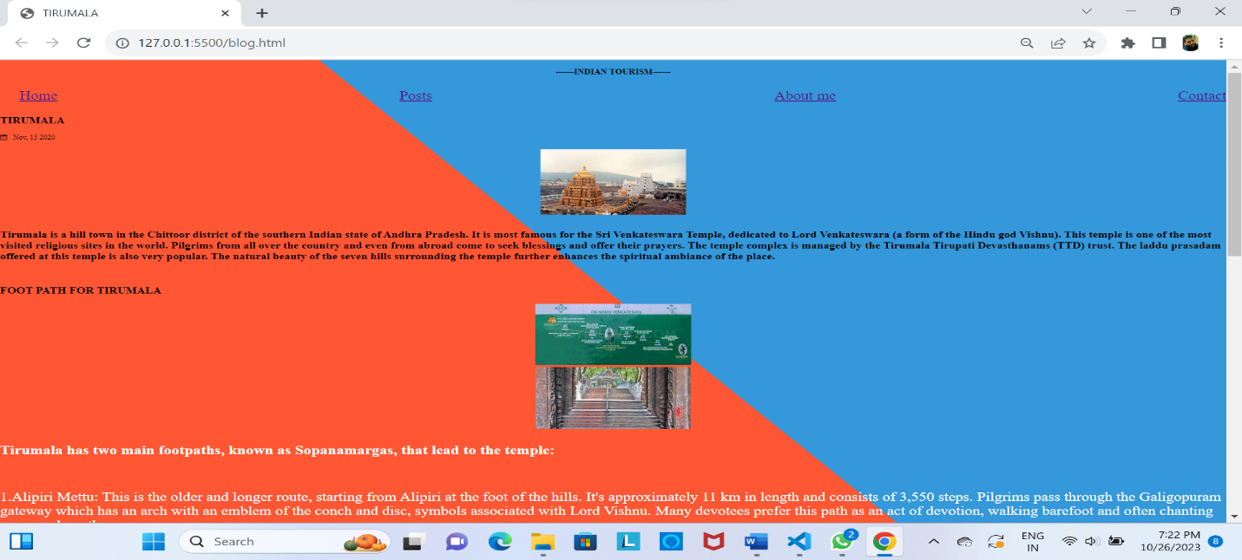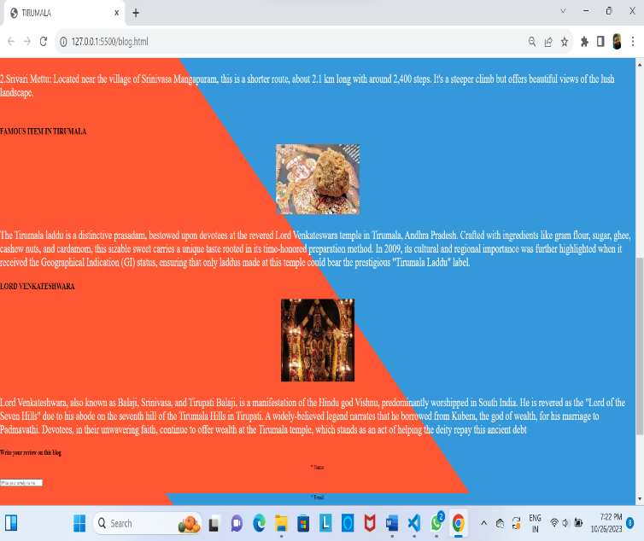

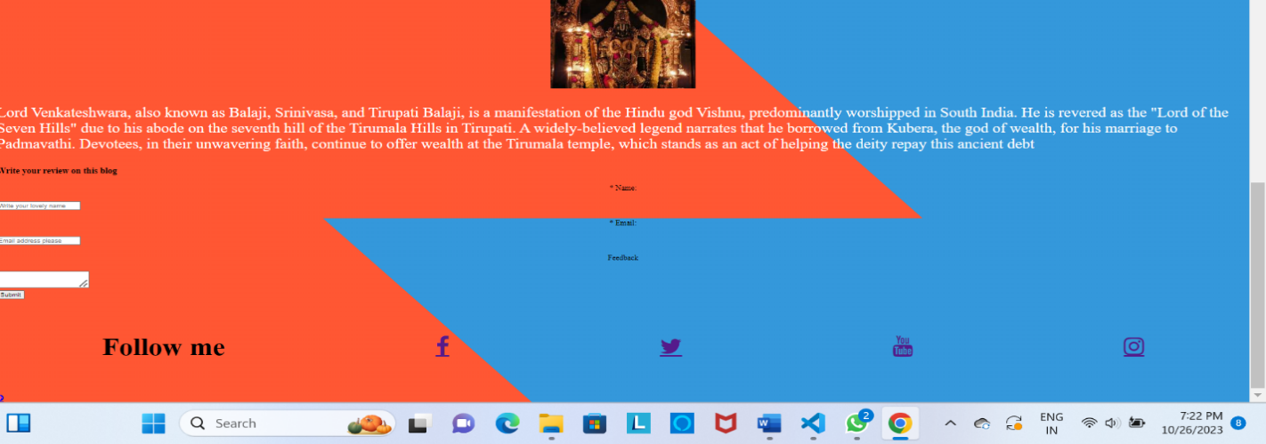

**Similarly you done code for the remaining blogs**

**Implementation Blog 2 code:**

|  |  |
| --- | --- |
| <!DOCTYPE html>  <html lang>  <head>      <title>Kanyakumari</title>      <!--CSS Blog post-->      <link rel="stylesheet" href="css\post.css">      <!-- Add icon library -->      <link rel="stylesheet" href="https://cdnjs.cloudflare.com/ajax/libs/font-awesome/4.7.0/css/font-awesome.min.css">      <link rel="stylesheet" href="./blog1.html">  </head>  <body>      <div id="container-post" class="container-post">          <!--Navigation bar-->          <nav id="nav"class="nav">              <div class="nav-menu flex-row">                  <div class="nav-brand">                      <CENTER><h3>------INDIAN TOURISM------</h3></CENTER>                  </div>                  <div>                    <ul class="nav-items">                      <li class="nav-link">                        <a href="index.html#nav">Home</a>                      </li>                      <li class="nav-link">                          <a href="index.html#post">Posts</a>                        </li>                      <li class="nav-link">                        <a href="index.html#about">About me</a>                      </li>                      <li class="nav-link">                        <a href="index.html#contact">Contact</a>                      </li>                    </ul>                   </div>              </div>          </nav>          <!--Post section-->          <section class="post">                <div class="post-box">                  <h1>Kanyakumari </h1>                  <span class="date-post"><i class="fa fa-calendar"></i>&nbsp;&nbsp; Nov, 15 2020</span><br><br>                  <center><img id="img-post" src="/kanya.jpeg" alt="Project"></center>                  <p id="post-p1">Kanyakumari District takes its name from the town of Kanyakumari, at the southern tip of India.This place has been a great center for art, culture, civilization, and pilgrimage for years. It was also a famous center for commerce and trade.                      This gigantic statue was built by the Tamil government in honour of the Saint Thiruvalluvar which is now one of the key attraction in Kanyakumari.                      Kanyakumari offers the marvellous confluence of the Bay of Bengal, the Arabian Sea and the Indian ocean meeting together at a point. But, this is not a miracle, the miracle lies in the beauty that the water of three seas does not mix, you can clearly distinguish between the turquoise blue, deep blue and sea green waters of the three seas. To enjoy the best view of sunset and sunrise, you can visit the Triveni Sangam point and the famous View towers                      The town has a mountainous terrain with elevated patches of hills, coconut trees and lined with paddy fields. Kanyakumari is also the only place in India where you can observe the sunrise and sunset at the same beach.                      The town is not only popular for its unique phenomenon but also its temples and the Vivekananda Rock Memorial among other iconic monuments.                  </p>                  <h2 id="hello">Best Places to Visit in Kanyakumari</h2>                  <p id="post-p1">Kanyakumari is a vibrant and culturally rich destination, offering a variety of attractions and activities for visitors. While it may be smaller than some other Indian cities, there is still plenty to see and do. The most famous attraction is undoubtedly Kanyakumari Beach, where you can witness the mesmerizing confluence of the Arabian Sea, Bay of Bengal, and Indian Ocean. The Vivekananda Rock Memorial and Thiruvalluvar Statue, located on a small island, are iconic landmarks with stunning sea views. You can also explore the historical places.</p>                  <h2 id="hello"><ol><li>Kanyakumari Beach</li>                      <center><img id="fl1" src="/oceanview.jpeg"></center>                      <p id="post-p">The Kanyakumari beach is a beautiful sight with multi-coloured sand. The beach here does not really offer one the opportunity to sunbathe on soft golden sands, or to frolic in the waves either. The seashore is rocky and dangerous, and there is a manmade wall running along it. People are warned to stay off the rocks, and when if someone ventures out of bounds, he or she is quickly and severely reprimanded by a watchful policeman. There is a lighthouse from where one can get a panoramic view.                          The sea is fairly rough, so it is entertaining to watch it beat itself against the rocks and then subside, before it gathers itself up for another attack. With long stretches of sands of many hues, the beach offers a welcome change. The place is also famous for its distinctly beautiful (reddish) sunrise and sunset. The confluence of three ocean bodies - the Bay of Bengal, the Indian Ocean, and the Arabian Sea - makes the sunrise and sunset even more special. On balmy, full-moon evenings one can also see the moon-rise and sunset at the same time - on either side of the horizon. A variety of shells are on sale on the Kanyakumari beach.                          Tamil Nadu State Transport Corporation runs a circular bus to visit tourist sports. Circular bus route - Kanyakumari to Kanyakumari via Vattakottai, Padmanabhapuram palace, Thottipalam, Pechipparai dam, Thirparappu Falls, Muttom beach and Suchindrum Sthanumalayan temple. The bus will start at 7 a.m. just after sunrise and return to Kanyakumari by 6 p.m. so that tourists can also view sunset on sea. The fare per trip is Rs. 200/- for adults and Rs. 100/- for children.</p>                        <li>Mukkudal Reservoir</li>                      <center><img id="fl1" src="/resovior.jpeg"></center>                      <p id="post-p">Mukkadal dam is built across the Vambaru River, 10 km from Nagercoil. It was built by Sree Chithira Thirunal Balarama Varma in 1945, the King of Travancore. The dam is constructed of clay and granite stones. The depth of water behind the dam is approximately 50 feet. The Mukkadal reservoir supplies water for Nagercoil Municipality, but ironically, not the people living near the dam, and it is also proposed to get water from here for Suchindrum and Kanyakumari. The dam and reservoir are surrounded by hills on three sides.                          It is a scenic place, favored as a picnic location among local residents. The forest are highly enhancing with pleasant shoals, hill top forests, beautiful grasslands, panoramic valleys, top hillocks, singing streams, vast stretches of rubber plantations, valuable Teak plantations and excellent climate. Nobody should miss seeing the enchanted view of this place.</p>                        <li>Wildlife Sanctuary</li>                      <center><img id="fl1" src="/forest.jpeg"></center>                      <p id="post-p">Kanyakumari Wildlife Sanctuary is a 402.4 km2 protected area in Kanyakumari district, Tamil Nadu South India declared in February 2008. The area is a tiger habitat. The area is a wildlife corridor with high biodiversity, and in addition to tigers, is home to the threatened species :Indian Bison, elephant, Indian Rock Python, Lion-tailed Macaque, Mouse deer, Nilgiri Tahr and Sambar deer. There are a few tribal villages in the sanctuary and adjoining reserve forests.                          Variety of wildlife can be seen in this division as follows:                          Bonnet Macaque, Common Langur or Hanuman Langur, Nilgiri Langur, Slender Loris, Tiger, Leopard or Panther, Jungle Cat, Small Indian Civet, Mangoose, Jackal, Indian Fox, Dhole or Indian Wild Dog, Sloth Bear, Otter, Large Brown Flying Squirrel, Flying Fox, Indian Giant Squirrel, Indian Porcupine, India Hare, Indian Elephant, Gaur or India Bison, Nilgiri Tahr, Chital or spotted Deer, Black Buck or Indian Antelope, Sambar, Barking Deer, Mousse Deer or India Chevrotain, Wild Boar, Pangolin.</p>                      <li>Gandhi Memorial</li>                      <center><img id="fl1" src="/gandhi.jpg"></center>                        <p id="post-p">Gandhi Memorial or Gandhi Mandapam was built in the memory of the ‘Father of the nation’ in 1956. Mohandas Karamchand Gandhi was shot in 1948 and after cremation his ashes were to be sprinkled over different regions of the country. And the Gandhi Memorial at Kanyakumari was the place where the ashes were kept for public viewing before being immersed into the sea.                          Interestingly, the height of the central dome of the memorial is 79 feet, the age of Gandhiji at the time of his assassination. It was constructed in such a manner that the sun's rays falls on the exact spot where his ashes were once laid. This occurs every year on his birthday on 2nd of October at 12 noon. Take the staircase to the terrace for a sweeping view of the sea and the town spanning the shores. Gandhi Mandapam will be open from 9:00 A.M to 6:00 P.M.</p>                      <li>Vivekananda Rock Memorial</li>                      <center><img id="fl1" src="/vivekananda.jpeg"></center>                      <p id="post-p">Vivekananda Rock Memorial is located about about 500 meters off the mainland. The views from here are fabulous – you can see the Kanyakumari town spread out on the banks and the colorful fishing boats moored in one part. The sea around has an overpowering presence, its roar blurs every other sound in the backdrop.                          It was built in 1970 by the Vivekananda Rock Memorial Committee in honor of their spiritual leader Swami Vivekananda. There is a ferry service to and from the rock memorial from Kanyakumari beach. The terrace is extremely windy and you will have to cross it to get into the various mandapams.                          Photography is not allowed and you need to take off your shoes outside the halls. It will be open from 9:00 A.M to 5:30 P.M. Entrance Fee: Rs.20/- for both child and adult.</p>                      </ol></h2>              </div>              <section id="contact1" class="contact1">                  <h1>Write your review on this blog</h1>                  <form class="form-contact">                      <label class="text-form" for="fullname">* Name: </label><br>                      <input type="text" id="name" name="fullname"  placeholder="Write your lovely name" required><br><br>                      <label class="text-form" for="email">* Email: </label><br>                      <input type="email" id="email" name="email"  placeholder="Email address please" required><br><br>                      <label class="text-form" for="message">Feedback </label><br>                      <textarea id="message" name="message"></textarea><br>                      <center><input class=" btn-submit" type="submit" value="Submit"></center>                  </form>              </section>              <footer class="footer">                  <div id="footer-grid">                      <div id="follow" class="footer-box">                          <h3>Follow me</h3>                          <a href="https://en-gb.facebook.com/login.php" class="fa fa-facebook"></a>                          <a href="https://twitter.com/?lang=en-in" class="fa fa-twitter"></a>                          <a href="https://www.youtube.com/" class="fa fa-youtube"></a>                          <a href="https://instagram.com/its__praveen_here_?igshid=NGVhN2U2NjQ0Yg==" class="fa fa-instagram"></a>                      </div>                      <div id="arrow-up">                          <a href="#nav" class="fa fa-arrow-circle-up"></a>                      </div>                  </div>              </footer>          </section>          <br><br><br>        </div>  </body>  </html> |  |

**Implementation CSS code for this blog2 :**

|  |
| --- |
| ul{      list-style: none;      font-size: 2rem;      display: flex;      align-items: center;      justify-content: space-between;  }  body{      margin: 0;      padding: 0;      height: 100vh;      background: linear-gradient(45deg, #FF5733 50%, #3498DB 50%);  }  .readbtn{      height: 5rem;      font-size: 1.5rem;      display: flex;      align-items: center;      justify-content: center;  }  .btntxt{      background-color: aliceblue;      width: 9rem;      height: 2rem;  }  p{      color: white;      font-size: 2rem;  }  .text-form{      display: flex;      align-items: center;      justify-content: center;  }  .footer-box{      display: flex;      align-items: center;      justify-content: space-around;      font-size: 3rem;  } |

**Output :  
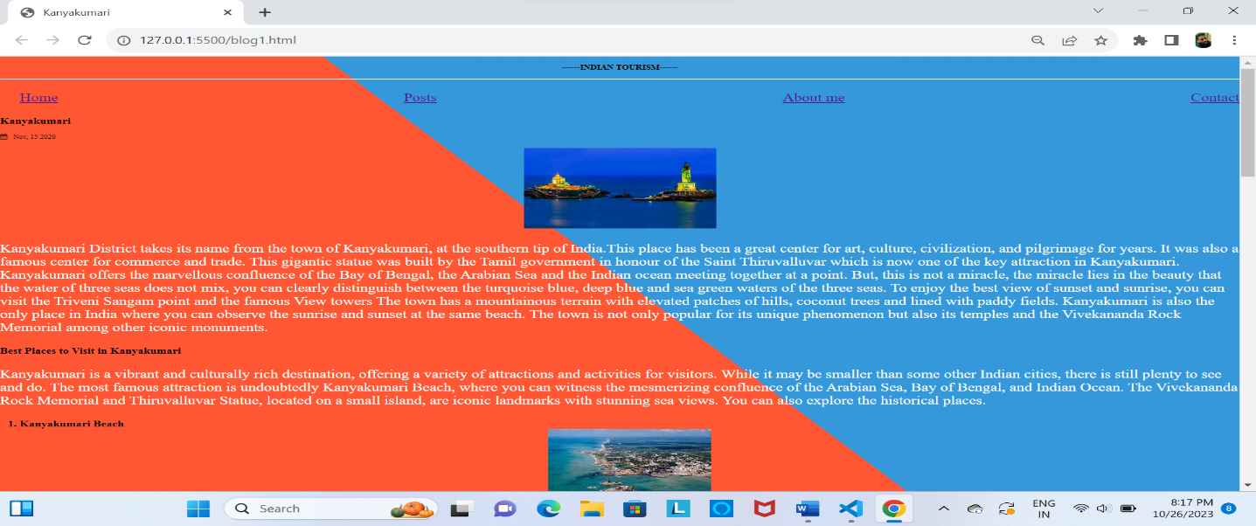**

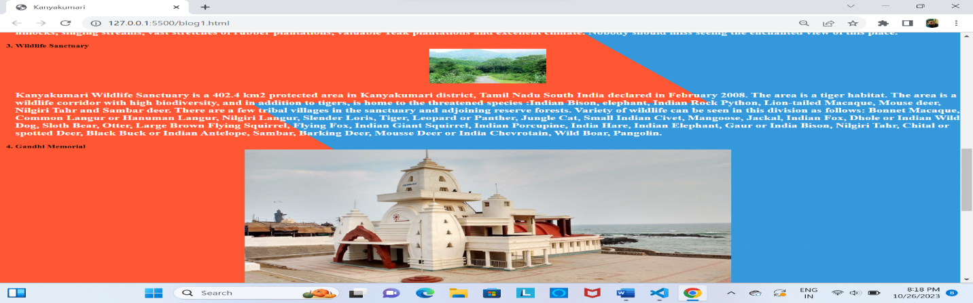

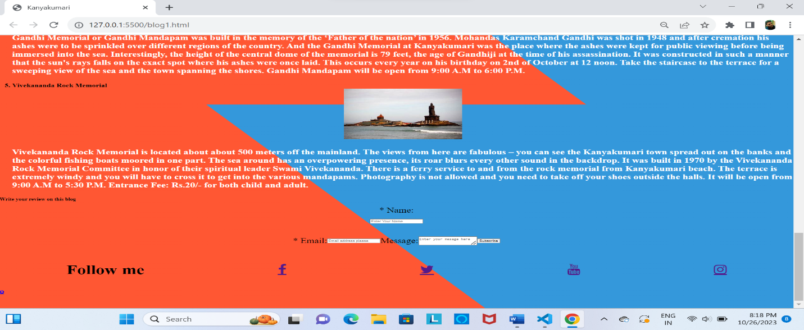

**Setting up the IBM cloud static web app and deploying the website**

**Previous phases we done the steps of creating account and host website in ibm cloud .**

**Click on create bucket and customize the bucket :**

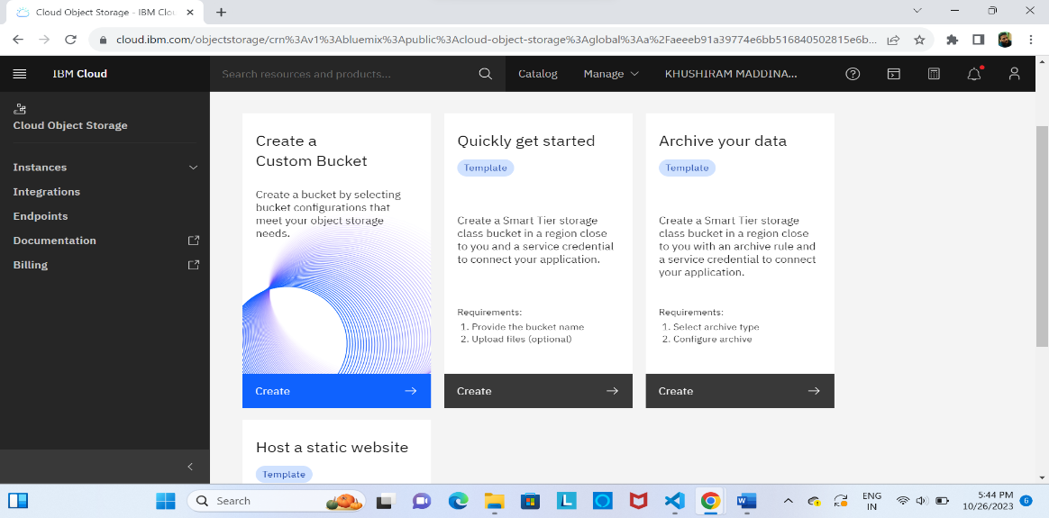

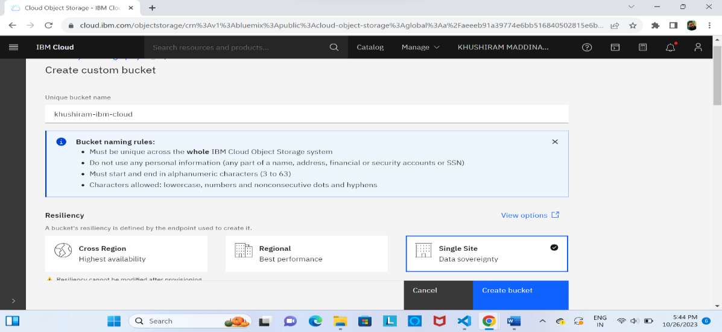

*Give the unique bucket name and set as single site then click on create bucket*

**Then you get interface like this:**

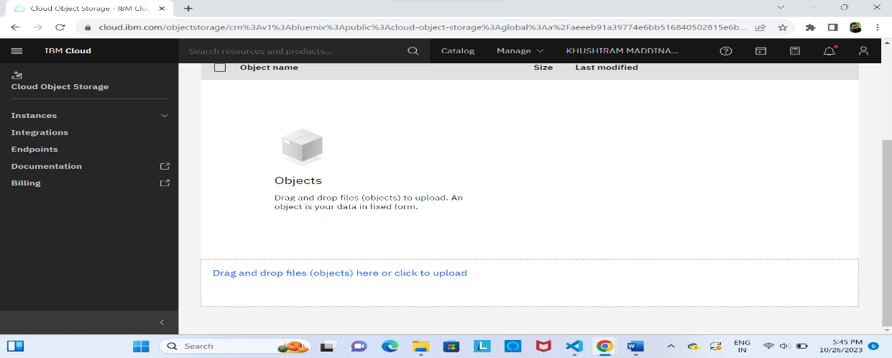

**Then you need to upload the html and css file in this objects :**

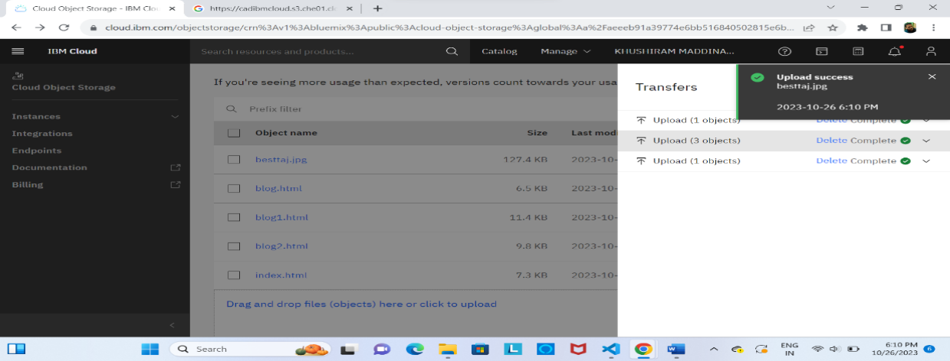

**After that you give public access for URL , click on cloud object storage :**

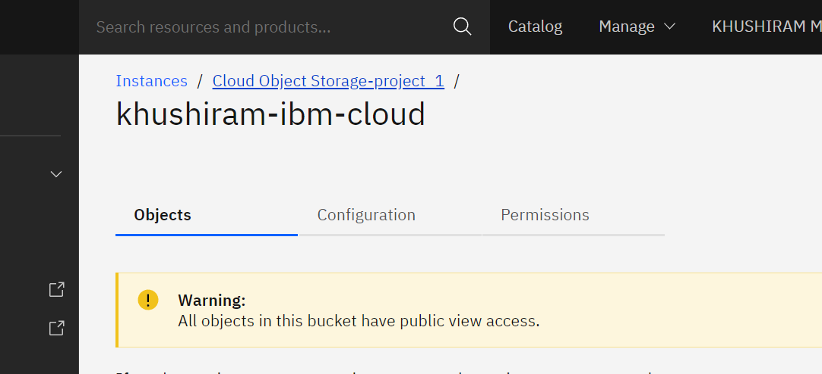

**Click on the three dots beside of your website object then click on Access Policies:**

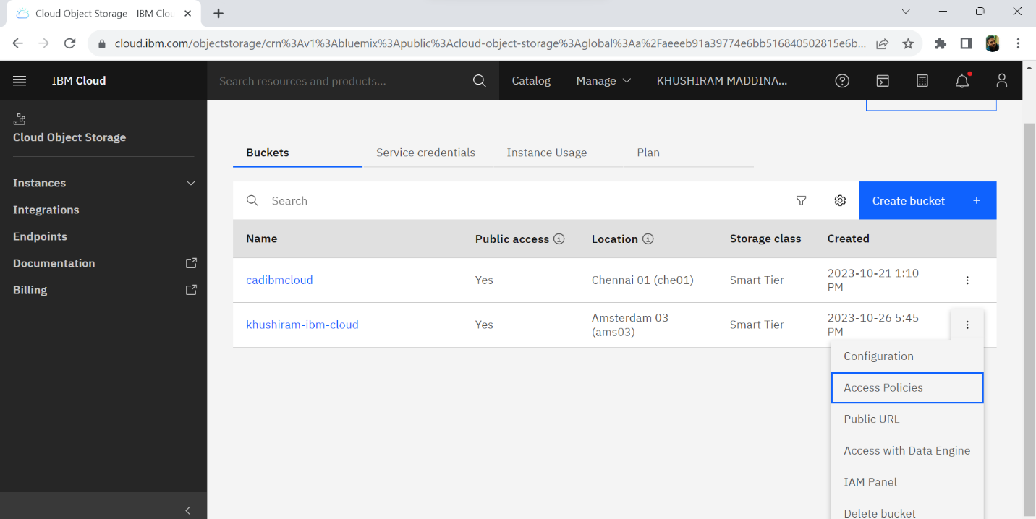

**Scroll down click on public access set as object reader :**

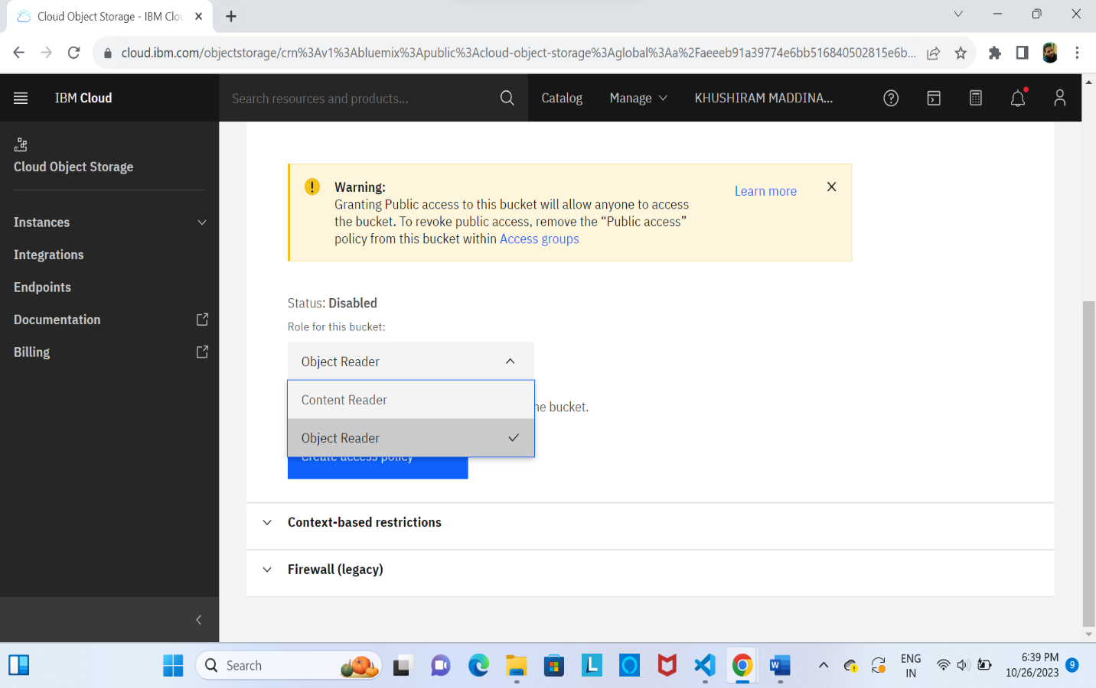

**Go to object files click on three dots and click on object details :**

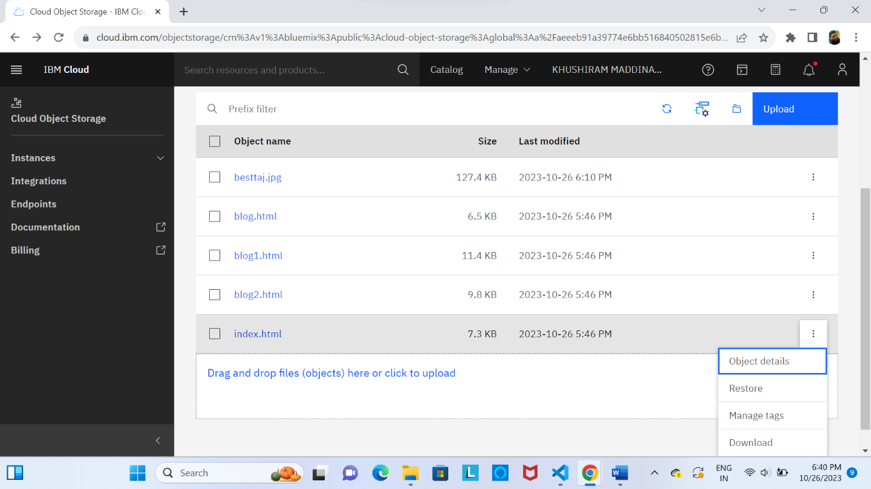

**You get object public link for public access :**

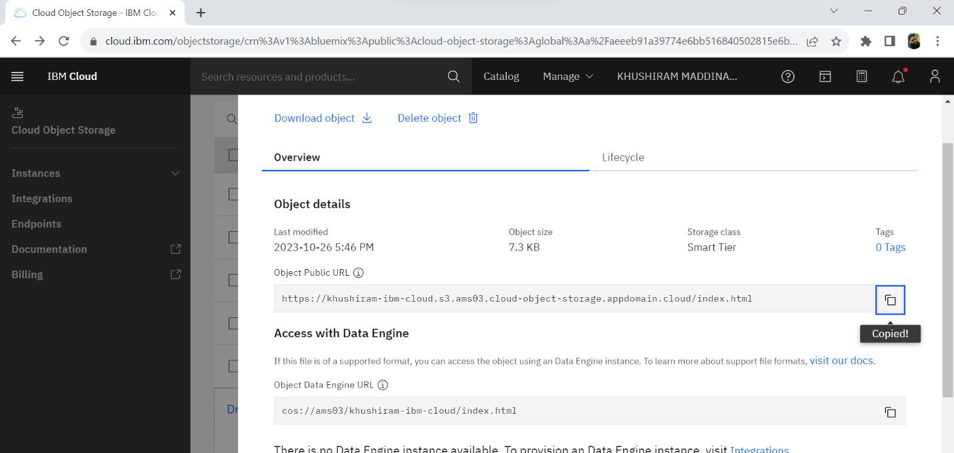

**Copy the link and paste it into new tab then click enter :**

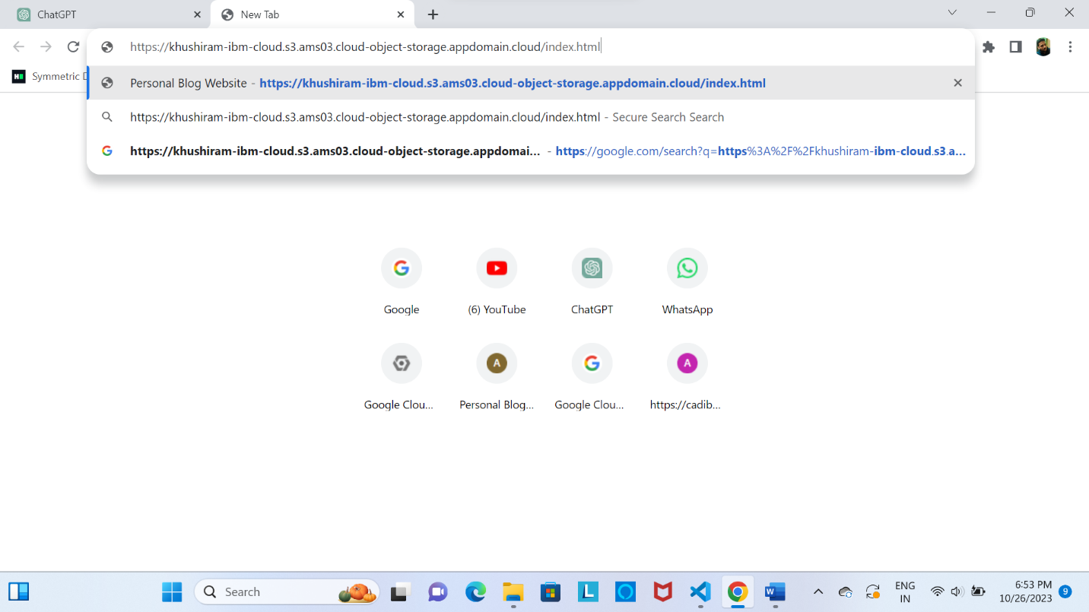

PUBLIC URL LINK FOR EXECUTE CODE IN LIVE IBM SERVER :

<https://khushiram-ibm-cloud12.s3.ams03.cloud-object-storage.appdomain.cloud/index.html>

conclusion :

In developing our travel blog website, we've crafted more than just a digital recounting of adventures; it's a vibrant showcase of the world's cultures, landscapes, and experiences. Designed with rich visuals, compelling narratives, and interactive features, our site serves as both inspiration and a resource for travelers. As technology and travel needs evolve, our platform will adapt, ever-focused on connecting a global community of explorers. Beyond being a mere collection of tales, this website is a gateway to the world's wonders, urging all to venture out, share their stories, and discover the beauty that lies beyond familiar horizons. Safe travels and happy blogging!